

**A**

**Project Report**

on

**Automated Attendance Portal: Using RFID and Facial Recognition**

submitted for partial fulfillment for the award of

**BACHELOR OF TECHNOLOGY**

**DEGREE**

in

**Computer Science**

By

Anand Parashar (2000290120023)

Antriksh Tyagi (2100290120023)

Devraj Gupta (2000290120062)

Ansh Srivastava (2000290120028)

**Under the Supervision of**

Mr. Anmol Jain

Assistant Professor

**Department of Computer Science  
KIET Group of Institutions, Ghaziabad**  
Affiliated to  
**Dr. A.P.J. Abdul Kalam Technical University, Lucknow  
May 2024**

# DECLARATION

I hereby declare that this submission is my work and that, to the best of my knowledge and belief, it contains no material previously published or written by another person nor material that to a substantial extent has been accepted for the award of any other degree or diploma of the university or other institute of higher learning, except where due acknowledgment has been made in the text.

Anand Parashar (2000290120023)

Antriksh Tyagi (2100290129004)

Devraj Gupta (2000290120062)

Ansh Srivastava (2000290120028)

Date:

# CERTIFICATE

This is to certify that the Project Report entitled “**Automated Attendance Portal: Using RFID and Facial Recognition.”** which is submitted by **Anand Parashar, Antriksh Tyagi, Devraj Gupta, Ansh Srivastava** in partial fulfillment of the requirement for the award of degree B. Tech. in the Department of Computer Science of Dr A.P.J. Abdul Kalam Technical University, Lucknow is a record of the candidate’s own work carried out by him under my supervision. The matter embodied in this report is original and has not been submitted for the award of any other degree.

Date:

##### Supervisor Signature

Mr. Anmol Jain

Assistant Professor

Department of Computer Science

# ACKNOWLEDGEMENT

It gives us a great sense of pleasure to present the report on the B. Tech Project undertaken during B. Tech. Final Year. We owe a special debt of gratitude to Mr. Anmol Jain (Asst. Prof.), Department of Computer Science, KIET Group of Institutions Ghaziabad, for his constant support and guidance throughout the course of our work. His sincerity, thoroughness and perseverance have been a constant source of inspiration for us. It is only his cognizant efforts that our endeavors have seen the light of the day.

We also take the opportunity to acknowledge the contribution of **Dr. Ajay Kumar Shrivastava**, Head of the Department of Computer Science, KIET Group of Institutions Ghaziabad, for his full support and assistance during the development of the project. We also do not want to miss the opportunity to acknowledge the contribution of all the faculty members of the department for their kind assistance and cooperation during the development of our project.

Finally, we acknowledge our family and friends for their contribution in the completion of the project.

Date :

Name : Anand Parashar Name: Antriksh Tyagi

Roll No.: 2000290120023 Roll No.:2100290129004

Name : Devraj Gupta Name: Ansh Srivastava

Roll No.: 2000290120062 Roll No.: 2000290120028

|  |  |
| --- | --- |
| **TABLE OF CONTENTS** |  |
| **Content** | **Page No.** |
| DECLARATION |  |
| CERTIFICATE |  |
| ACKNOWLEDGEMENTS |  |
| ABSTRACT……………………………………………………………………….... | i |
| LIST OF FIGURES…………………………………………………………………. | ii |
| LIST OF TABLES…………………………………………………………………… | iii |
| LIST OF ABBREVIATIONS………………………………………………………. | iv |
| CHAPTER1 INTRODUCTION  1.1 Introduction to Project  1.2 Project Category  1.3 Objectives  1.4 Structure of The Report  CHAPTER 2 LITERATURE REVIEW  2.1 Literature Review  2.2 Research Gaps  2.3 Problem Formulation  CHAPTER 3 PROPOSED SYSTEM  3.1 Proposed System  3.2 Unique Features of The System  CHAPTER 4 REQUIREMENT ANALYSIS AND SYSTEM SPECIFICATION  4.1 Feasibility Study (Technical, Economical, Operational)  4.2 Software Requirement Specification  4.2.1 Data Requirement  4.2.2 Functional Requirement  4.2.3 Performance Requirement  4.2.4 Maintainability Requirement  4.2.5 Security Requirement  4.3 SDLC Model Used  4.4 System Design  4.4.1 Data Flow Diagrams  4.4.2 Use Case Diagrams  4.5 Database Design  CHAPTER 5 IMPLEMENTATION  5.1 Introduction Tools and Technologies used.  5.2 Dataset Description  CHAPTER 6 TESTING, AND MAINTENANCE  6.1 Testing Techniques and Test Cases Used  CHAPTER 7 RESULTS AND DISCUSSIONS  7.1 Description of Modules with Snapshots  7.2 Key findings of the project  7.3 Brief Description of Database with Snapshots  7.4 User Interface Representation  7.5 Presentation of Results  CHAPTER 8 CONCLUSION AND FUTURE SCOPE  REFERENCES  Research Paper Acceptance Proof  Research Paper (If Presented/ Published)  Proof of patent publication (Screenshot of Publication) | 1 |

# 

# ABSTRACT

The management of the attendance can be a great burden on the teachers if it is done by hand. To resolve this problem, a smart and auto attendance management system is being utilized. But authentication is an important issue in this system. The smart attendance system is generally executed with the help of biometrics. Face recognition is one of the biometric methods to improve this system. Being a prime feature of biometric verification, facial recognition is being used enormously in several such applications, like video monitoring and CCTV footage system, an interaction between computer & humans and access systems presents indoors and network security. By utilizing this framework, the problem of proxies and students being marked present even though they are not physically present can easily be solved. The main implementation steps used in this type of system are face detection and recognizing the detected face.

Automatic face recognition (AFR) technologies have made many improvements in the changing world. Smart Attendance using Real-Time Face Recognition is a real-world solution which comes with day-to-day activities of handling student attendance system.

Face recognition-based attendance system is a process of recognizing the students face for taking attendance by using face biometrics based on high - definition monitor video and other information technology.

It helps in conversion of the frames of the video into images so that the face of the student can be easily recognized for their attendance so that the attendance database can be easily reflected automatically.

This paper proposes a model for implementing an automated attendance management system for students of a class by making use of face recognition technique, by using Eigenface values, Principal Component Analysis (PCA) and Local Binary Patterns Histograms (LBPH) algorithm. After these, the connection of recognized faces ought to be conceivable by comparing with the database containing student's faces. This model will be a successful technique to manage the attendance and records of students.

|  |  |  |
| --- | --- | --- |
|  | **LIST OF FIGURES** |  |
| Figure No. | Description | Page no. |
| Fig 3.1 | System Model of Face Detection & Recognition | 15 |
| Fig 4.1 | System Architecture | 16 |
| Fig 4.2 | Level-0 DFD Diagram | 17 |
| Fig 4.3 | Level-1 DFD Diagram | 18 |
| Fig 4.4 | Level-2 DFD Diagram | 19 |
| Fig 4.5 | Level-3 DFD Diagram | 20 |
| Fig 4.6 | Level-4 DFD Diagram | 21 |
| Fig 4.7 | Use Case Diagram | 22 |
| Fig 4.8 | ER Diagram | 23 |
| Fig 5.1  Fig 6.1  Fig 6.2  Fig 6.3  Fig 6.4 | The 5-Haar Like Features Used  Test Case 1 (Admin Login)  Test Case 2 (Teacher Login)  Test Case 3(Admin Dashboard)  Teat Case 4(Teacher Dashboard) | 24 |
| Fig 7.1 | Attendance_cam_virtual.py Module | 25 |
| Fig 7.2 | Train.py Module | 26 |
| Fig 7.3 | Variety of PHP Modules | 28 |
| Fig 7.4 | Subjects Schema | 31 |
| Fig 7.5 | Students Schema | 34 |
| Fig 7.6 | Subjects Panel |  |
| Fig 7.7 | Teachers Panel |  |
| Fig 7.8  Fig 7.9 | Timetable Panel  Classes Panel |  |
| Fig 7.10 | Teacher Login |  |
| Fig 7.11 | Admin Login |  |
| Fig 7.12 | Practical Testing |  |
| Fig 7.13 | Practical Testing 1 |  |
|  |  |  |
|  |  |  |
|  |  |  |
|  |  |  |

**LIST OF TABLES**

|  |  |  |
| --- | --- | --- |
| Table No. | Description | Page Number |
| Table   7.1 | Recognition Rate at Different Angles | 32 |

**LIST OF ABBREVIATIONS**

|  |  |
| --- | --- |
| **Abbreviation** | **Definition** |
| CNN | Convolutional Neural Networks |
| CV | Computer Vision |
| EAR | Eye Aspect Ratio |
| LBPH | Local Binary Pattern Histograms |
| HCC A | Haar Cascade Classifier |
| GUI | Graphical User Interface |
| RFID | Radio Frequency Identification |
| XAMPP | X-Operating System, Apache, Mysql, Php, Perl |

**CHAPTER 1**

**INTRODUCTION**

**1.1 Introduction**

Attendance systems of old practices are not quite efficient. Now a days for keeping track on student’s attendance. Student enrollment in schools and colleges is increasing every year and each student’s attendance plays a very important role. So, it is necessary to discuss an effective system which records the attendance of a student automatically. Maintaining attendance is very important in all the colleges for checking the performance of students. Every college has its own method in this regard. Some are taking attendance of students manually using attendance registers or marking attendance sheets or file-based approach and some have adopted the methods of automatic attendance using some biometric techniques. But in these methods, students must wait for a long time in a queue at the time they enter inside the classroom.

Many biometric systems are available in the market, but the key authentications are the same in all the techniques. Every biometric system consists of an enrollment process in which the unique feature of a person is stored in the database and after that, there are some processes of identification and verification of the person. These two processes compare the biometric features of a person with previously stored template captured at the time of enrolment of a student. Biometric templates can be of many types like Fingerprints, Eye Iris, voice etc. Our system uses the face recognition approach for the automatic attendance of the students in the classroom environment without student intervention. The purpose of developing the new attendance management system is to computerize the traditional methods of taking the attendance. Therefore, to draw the attention of students and make them interactive in observing technologies, we try to move on to the latest upcoming trends in developing attendance systems. This is the reason for the college attendance management system to come up with an approach that ensures a strong contribution of students in classrooms.

To track the attendance of the students, we have introduced the attendance management system. With the introduction of this attendance system, skipping classes for students without the staff’s knowledge has become difficult. The attendance management system is to count the number of students and urge students to attend the classes on time, to improve the quality of teaching.

**1.2 Project Category**

**Project Category: System Development/Application Development**

1. **System Development:**
   1. The project involves the development of a comprehensive system for managing student attendance.
   2. This includes designing and implementing various software components to facilitate attendance recording, tracking, and reporting.
2. **Application Development:**
   1. The core focus of the project is to create a software application tailored specifically for managing attendance within educational institutions.
   2. This application will likely include a user-friendly interface accessible to teachers and administrators for inputting and accessing attendance data.
   3. Additionally, the application will involve backend development to handle data storage, processing, and management.

**Reasoning:**

1. The project revolves around developing a software solution to address a specific need: managing student attendance efficiently.
2. While internet-based technologies may be used for certain functionalities (such as remote access or cloud storage), the primary objective is not centred around internet-based services.
3. Research-based projects typically involve conducting extensive research to explore new concepts, theories, or technologies. While the project may involve some research into existing attendance management systems and best practices, it is primarily focused on implementing a functional solution rather than advancing theoretical knowledge.
4. Industry automation projects typically involve automating specific tasks or processes within industries to improve efficiency or productivity. While the attendance management system could enhance efficiency within educational institutions, it is not primarily focused on industrial automation.
5. Network or system administration projects involve managing and maintaining computer networks or systems. While the attendance management system may require considerations for network infrastructure and system requirements, its primary focus is on software development rather than network/system administration.

**1.3 Objectives**

As we aim to build an automated attendance portal which is on web version to automate the attendance through face recognition. Objectives are as follows-

1. Develop a Robust Face Recognition System.
2. Integrate Face Recognition with PHP Backend.
3. Automate Attendance Tracking Process
4. Ensure Data Security and Privacy.
5. Provide User-Friendly Interface.
6. Support Scalability and Customization.
7. Facilitate Integration with Existing Systems.
8. Ensure Accessibility and Usability.

**1.4 Structure of Report**

1. **Introduction**: In this section, we provide a succinct overview of our human drowsiness detection project, outlining its objectives and significance. We highlight the project's aim to develop an efficient attendance management system using facial recognition and also the use of RFID tags for its potential impact on user convenience and productivity.

1. **Literature Review**: The literature review delves into existing research and discourse surrounding attendance management system. We analyze the evolution of facial recognition technology, discussing advancements, user experiences, and pertinent security and privacy concerns.
2. **Proposed System**: This chapter outlines our proposed attendance management system, detailing its functionalities and the technologies utilized for its implementation. We elucidate the system's capabilities and how it addresses user requirements.
3. **Requirement Analysis and System Specification**: Here, we conduct a feasibility study of our proposed system and provide a detailed software requirement specification. We discuss the chosen SDLC model and its relevance to the project's development.
4. **Implementation**: In this section, we present an overview of the languages, tools, and technologies employed for implementing the attendance management system. We delve into the libraries and algorithms utilized, offering insights into the implementation process and key modules.

1. **Testing and Maintenance**: This chapter focuses on testing techniques and methodologies utilized to ensure the functionality and reliability of our attendance management system. We discuss unit testing, integration testing, functional testing, usability testing, and performance testing, along with details of the test environment.
2. **Results and Discussions**: Here, we provide a summary of the various modules comprising the voice assistant system and discuss the outcomes of our project. We analyze the results, interpret their implications, and offer insights into the findings.

1. **Conclusion:** In the conclusion, we encapsulate the project's objectives, achievements, and contributions. We reflect on key findings, discuss potential future research directions, and underscore the significance of our work.
2. **References:** The references section includes citations of relevant research papers, articles, and sources used throughout the report, ensuring transparency and academic integrity.

**CHAPTER 2**

**LITERATURE REVIEW**

**2.1 Literature Review**

In this project we have discussed a variety of topics in brief which are related to the system methodologies, algorithms, emerging technologies, advancements, future directions etc.

**Introduction:** Attendance management is a fundamental aspect of educational institutions, ensuring accountability, monitoring student engagement, and facilitating effective teaching practices. Traditional methods of attendance tracking, such as manual paper-based systems, have long been the norm. However, these methods are prone to errors, time-consuming, and lack real-time monitoring capabilities. With the advent of digital technologies, there has been a paradigm shift towards automated attendance management systems, leveraging advancements in face recognition technology to streamline administrative processes and enhance efficiency.

**Advancements in Face Recognition Technology:** Recent years have witnessed significant advancements in face recognition technology, driven by breakthroughs in computer vision, machine learning, and artificial intelligence. Techniques such as Local Binary Patterns Histograms (LBPH) and Cascade Classifiers have emerged as powerful tools for face detection and recognition. These methods are capable of accurately identifying individuals from images or video streams, even in challenging conditions such as varying lighting, facial expressions, and occlusions.

**Integration of Face Recognition in Attendance Management:** The integration of face recognition technology into attendance management systems represents a promising solution to the limitations of traditional attendance tracking methods. By automating the process of capturing and verifying student identities, these systems offer several advantages, including improved accuracy, real-time monitoring, and reduced administrative burden. Studies have shown that face recognition-based attendance systems can significantly enhance efficiency, enabling educators to focus more on teaching and student engagement.

**Case Studies and Implementations**: Numerous case studies have demonstrated the successful implementation of face recognition-based attendance management systems in educational institutions worldwide. These implementations vary in terms of system architecture, hardware requirements, and user interface design. For example, some institutions have deployed standalone face recognition terminals, while others have integrated facial recognition capabilities into existing infrastructure such as student ID cards or mobile applications. Common themes across these case studies include the importance of user training, data privacy safeguards, and ongoing system maintenance to ensure the reliability and effectiveness of the attendance management system.

**Emerging Trends and Future Directions:** Looking ahead, emerging trends in face recognition technology are poised to further revolutionize attendance management systems. Deep learning models, such as convolutional neural networks (CNNs), hold promise for achieving even higher levels of accuracy and robustness in face recognition tasks. Additionally, the adoption of cloud-based solutions and mobile applications is expected to grow, offering scalability, flexibility, and accessibility for educational institutions of all sizes. Future research directions may focus on addressing challenges related to scalability, interoperability, and ethical considerations surrounding the use of biometric data in educational settings.

**Conclusion:** In conclusion, automated attendance management systems powered by face recognition technology represent a significant advancement in the field of educational technology. By leveraging state-of-the-art face recognition algorithms and digital infrastructure, these systems offer educators and administrators a powerful tool for improving efficiency, accountability, and student engagement. As the technology continues to evolve, ongoing research and development efforts are essential to ensure the effectiveness, reliability, and ethical use of face recognition-based attendance management systems in educational environments.

**2.2 Research Gaps**

In this section we provide some points which highlights the areas where further investigation or development of the project is needed-

**Exploring boundary limits*:*** Despite the rapid advancements in face recognition technology and its integration into attendance management systems, there exist several unexplored avenues and research gaps that warrant attention. One such area is the exploration of novel algorithms and methodologies tailored specifically for the unique requirements of educational environments. While existing face recognition techniques have shown promise, their application in real-world scenarios within educational institutions presents distinct challenges that have yet to be fully addressed.

**Addressing Ethical and Privacy Concerns:** A critical research gap lies in the ethical and privacy considerations surrounding the deployment of face recognition-based attendance management systems in educational settings. While these systems offer numerous benefits, including enhanced efficiency and accuracy, they also raise significant concerns regarding data security, consent, and potential misuse of biometric data. Further research is needed to develop robust frameworks and guidelines for ensuring the ethical use and protection of sensitive student information within the context of face recognition technology.

**Optimizing System Performance and Scalability*:*** Another research gap pertains to the optimization of system performance and scalability of face recognition-based attendance management systems. While existing solutions demonstrate efficacy under controlled conditions, their performance may degrade in real-world environments with large student populations, diverse demographics, and varying environmental factors. Research efforts focusing on enhancing the scalability, reliability, and adaptability of these systems to accommodate dynamic educational settings are essential for their widespread adoption and long-term sustainability.

**User-Centric Design and User Experience:** User-centric design and user experience represent yet another research gap in the development of face recognition-based attendance management systems. While the technical aspects of these systems are critical, equally important is the usability, acceptance, and satisfaction of end-users, including educators, administrators, and students. Research endeavours aimed at understanding user needs, preferences, and pain points can inform the design of intuitive interfaces, personalized interactions, and seamless integration with existing workflows, thereby enhancing user adoption and system effectiveness.

**Integration with Educational Pedagogy**: Finally, there is a research gap in the integration of face recognition technology with educational pedagogy and instructional practices. While attendance management systems serve as valuable administrative tools, their potential to support teaching and learning processes remains largely untapped. Research exploring innovative ways to leverage attendance data, student engagement metrics, and feedback mechanisms to inform instructional decision-making, personalize learning experiences, and foster student success is needed to unlock the full educational potential of face recognition-based attendance management systems.

In summary, addressing these research gaps requires interdisciplinary collaboration, stakeholder engagement, and a commitment to ethical principles, innovation, and continuous improvement. By bridging these gaps, researchers and practitioners can contribute to the advancement of face recognition technology in education and the creation of more inclusive, efficient, and equitable learning environments for all.

**2.3 Problem Formulation**

When there are so many students in a college, it becomes more and more difficult to mark attendance for each student and it is time consuming too. The Existing system of any institute is a manual entry for the students. This system faces the issue of wastage of time and becomes complicated when the strength is more than usual. Here, the attendance is being carried out in the handwritten registers. It is a very tedious job for us to maintain the record of the user.

Whenever we must measure the performance of students, finding and calculating the average attendance of each enrolled student is also a very complicated task for us. Human effort is more here. The retrieval of the information is not a piece of cake as the records are maintained in the handwritten registers. This existing system requires correct feed on input into the respective field. Therefore, we need an automated system for marking and maintaining attendance of the students. Let us suppose that the wrong inputs are entered, the application resist to work. So, the user finds it difficult to use the existing system.

**CHAPTER 3**

**PROPOSED SYSTEM**

**3.1 Proposed System**

In our proposed system, the system is instantiated by the mobile. After it triggers then the system starts processing the image of the students for which we want to mark the attendance.

Image Capturing phase is one in which we capture the image of the students. This is the very basic phase from which we start initializing our system. We capture an image from our camera which predominantly checks for certain constraints like lightning, spacing, density, facial expressions etc. The captured image is resolute according to our requirements. Once it is resolute, we make sure it is either in .png or .jpeg format.

We take different frontal postures of an individual so that accuracy can be attained to the maximum extent. This is the training database in which we classify every individual based on labels. For the captured image, from every object we detect only frontal faces. This detects only face and removes every other part since we are exploring the features of faces only. These detected faces are stored somewhere in the database for further enquiry. Features are extracted in the extraction phase.

The detected bounding boxes are further queried to look for features extraction and the extracted features are stored in a matrix. For every detected phase, this feature extraction is done. Features that we look here are shape, edge, color, auto-correlation, and LBP. Face is recognized once we complete the extracting features. The features which are already trained with every individual is compared with the detected faces features and if both features match, then it is recognized. Once it recognizes, it is going to update in the student attendance database. Once the process is completed, the testing images remain.

Usually, a roll no. call is taken to determine whether the student is present in the class or not, which usually wastes a lot of time. In recent years, with the emerging technology and with the development of deep learning, face recognition has made great achievements, which leads us to a new way of thinking to solve the problem of student enrollment. So, to save time, the idea to count the number of students in a class automatically based on face recognition is incorporated. This system is developed by using face recognition technique which is used to detect the face of an individual. There are many different face recognition algorithms introduced to increase the efficiency of the system. The system provides an increased accuracy due to the use of many features like Shape, color, LBPH, Auto- Correlation etc. of the face. However, face recognition remains a challenging problem for us because of its fundamental difficulties regarding various factors like illumination changes, face rotation, facial expression etc.

**Fig 3.1 System Model of Face Detection & Recognition**

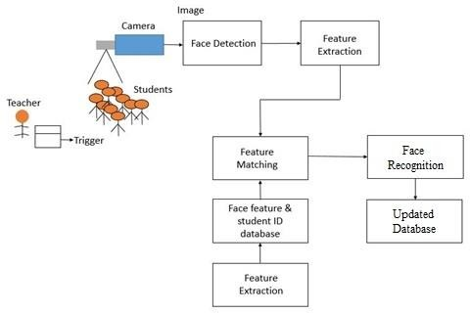

**3.2 Unique Features of The System**

The attendance management system presented in this project incorporates several unique features that set it apart from traditional methods of attendance tracking. Some of these distinctive features include: -

1. **RFID Integration:** The system utilizes RFID technology to streamline the attendance recording process. Each student is issued an RFID card or tag, which they can scan upon entering the classroom to mark their attendance automatically.
2. **Biometric Recognition:** In addition to RFID scanning, the system may also support biometric recognition methods such as fingerprint or facial recognition. This provides an additional layer of security and ensures that attendance records are accurate and tamper-proof.
3. **Real-Time Data Updates**: Attendance data is updated in real-time, allowing teachers and administrators to access the latest attendance information instantly. This ensures that educators have timely insights into student attendance patterns and can take appropriate action as needed.
4. **Customizable Reporting:** The system offers customizable reporting and analytics tools, allowing educators to generate detailed attendance reports tailored to their specific requirements. This enables them to analyze attendance trends, identify patterns, and make data-driven decisions to improve student outcomes.
5. **Automated Notifications**: The system can send automated notifications to students, parents, and teachers regarding attendance-related matters. This may include notifications for absentees, late arrivals, or unauthorized absences, helping to improve communication and accountability.
6. **Integration with Learning Management Systems (LMS):** The system may integrate seamlessly with existing learning management systems used by educational institutions. This allows for the seamless exchange of data between the attendance management system and other educational platforms, streamlining administrative processes.
7. **Scalability and Customization:** The system is designed to be scalable and customizable to meet the unique needs of different educational institutions. Whether managing attendance for a small classroom or a large university campus, the system can adapt to accommodate varying class sizes, schedules, and attendance policies.

**CHAPTER 4**

**Requirement Analysis and System Specification**

**4.1 Feasibility Study (Technical, Economical, Operational)**

**TECHNICAL Feasibility Study-**

**a) Hardware Requirements:**

1. Desktop, CPU (Normal computer system), RFID Scanner(optional).

b) **Software requirements:**

1. Programming languages (Python, PHP).
2. Frameworks and Libraries (Open CV, Python libraries (requests, NumPy, datetime, Serial)),
3. Database management (My SQL),
4. Integrated Development Environment (Visual Studio Code)
5. Virtual environment (Anaconda Navigator (Anaconda 3))
6. XAMPP (For testing of PHP backend and MySQL database)
7. Apache HTTP server (for hosting the PHP based backend and serving web pages to clients)

c**) Scalability:**

1. Increase in Users: As more teachers and administrative staff members use the system to manage attendance for various classes and subjects, the number of concurrent users accessing the system may increase. The system is designed to accommodate this growth in user activity without experiencing slowdowns or performance issues.
2. Data Volume: Over time, the attendance management system will accumulate a large volume of attendance records for multiple classes, subjects, and students. The system's database can efficiently store and retrieve this data, even as it grows. Additionally, the system supports efficient data processing and analysis to generate reports and insights from the attendance data.
3. Load Balancing: To ensure scalability, the system can implement load balancing techniques to distribute incoming user requests evenly across multiple servers or resources. This helps prevent any single server from becoming overwhelmed with requests and ensures consistent performance for all users.
4. Resource Allocation: The system can dynamically allocate resources such as CPU, memory, and storage based on the current workload and demand. This ensures optimal utilization of resources and prevents bottlenecks that could hinder system performance during peak usage periods.

**d)Integration:**

In this project all PHP units are easily integrable because of viewability and intractability of all units of software. The routes of all PHP pages must be predefined to understand the workflow of the website.

**OPERATIONAL Feasibility:**

1. **User Acceptance**:
   1. Teachers: Determine if teachers are willing to adopt the attendance management system as part of their daily routine. This involves understanding their attitudes towards technology adoption, their perceived benefits of using the system, and addressing any concerns they may have regarding its implementation.
   2. Administrators: Assess the willingness of school administrators to support the deployment and maintenance of the system. This includes evaluating their understanding of the system's functionalities, their expectations regarding its impact on administrative tasks, and their commitment to providing necessary resources for its successful implementation.
   3. Other Stakeholders: Consider the perspectives of other stakeholders such as students, parents, and regulatory bodies. Understand their expectations, concerns, and requirements regarding attendance tracking and reporting.
2. **Training Needs**:
   1. Teachers: Identify the training requirements for teachers to effectively use the attendance management system. This may include training sessions on system navigation, data entry, attendance recording procedures, and troubleshooting common issues.
   2. Administrators: Determine the training needs for school administrators responsible for managing user accounts, configuring system settings, generating reports, and addressing technical issues. Provide comprehensive training programs to ensure administrators can fulfil their roles effectively.
   3. Technical Support: Establish a support mechanism to address user queries, provide technical assistance, and offer ongoing training and guidance as needed.
3. **Legal and Regulatory Compliance**:
   1. Data Privacy: Ensure that the attendance management system complies with relevant data privacy laws and regulations, such as the General Data Protection Regulation (GDPR) or the Family Educational Rights and Privacy Act (FERPA). Implement robust data protection measures, including encryption, access controls, and user consent mechanisms, to safeguard sensitive attendance information.
   2. Security: Implement security measures to protect the system from unauthorized access, data breaches, and cyber threats. This includes regular security audits, vulnerability assessments, and adherence to industry best practices for secure software development.
   3. Attendance Tracking Regulations: Ensure that the system adheres to local educational regulations and institutional policies regarding attendance tracking, reporting, and record-keeping. This may include compliance with government-mandated attendance requirements, accreditation standards, and audit procedures.
4. **Ease of Use**:
   1. User Interface Design: Design an intuitive and user-friendly interface that simplifies attendance tracking and reporting tasks for teachers, administrators, and other stakeholders. Incorporate features such as clear navigation menus, interactive dashboards, and customizable views to enhance usability.
   2. Mobile Accessibility: Ensure that the system is accessible from a variety of devices, including desktop computers, laptops, tablets, and smartphones. Develop responsive web interfaces and native mobile applications that adapt to different screen sizes and input methods, allowing users to access attendance data anytime, anywhere.
   3. User Feedback: Gather feedback from users through surveys, focus groups, and usability testing sessions to identify areas for improvement and refine the system's usability over time. Incorporate user feedback into iterative design updates and continuous improvement processes to enhance user satisfaction and adoption rates.

**4.2 Software Requirement Specification**

The Software Requirements Specification (SRS) document for this project serves as a comprehensive blueprint outlining the functional, non-functional, and technical requirements of the attendance management system. It delineates the system's scope, objectives, and constraints while providing detailed specifications for its features, interfaces, and performance criteria. The SRS document establishes a common understanding between stakeholders, including developers, users, and project managers, ensuring alignment with project goals, and facilitating effective communication throughout the software development lifecycle. Additionally, it serves as a reference guide for system design, implementation, testing, and maintenance activities, thereby contributing to the successful delivery of a robust, user-friendly, and scalable attendance management solution tailored to the needs of educational institutions.

In this project we need to fulfill a variety of requirements related to data, functional/non-functional etc. Pointwise, we have discussed about all requirements as follows-:

**4.2.1. Data Requirement:**

* Student Information: The system requires a database to store student information, including roll numbers, names, and optionally, photographs.
* Class Information: Information about classes, such as class names and subjects, needs to be stored for attendance tracking.
* Attendance Records: The system must maintain records of student attendance, including date, class, subject, and attendance status (present or absent).
* RFID Data: If RFID technology is used for attendance tracking, the system needs to store RFID tags associated with teachers.

**4.2.2. Functional Requirement:**

* User Authentication: Users (teachers and administrators) must authenticate themselves before accessing the system.
* Attendance Recording: Teachers can record student attendance for specific classes and subjects.
* View Attendance: Users can view attendance records for individual students, classes, or dates.
* Attendance Modification: Authorized users can modify attendance records if necessary.
* Reporting: The system generates reports summarizing attendance data, such as attendance percentages, trends, and student-specific reports.
* RFID Integration: If RFID technology is used, the system should integrate with RFID scanners to automatically record student attendance.

**4.2.3. Performance Requirement:**

* Response Time: The system responds to user interactions (e.g., logging in, recording attendance) within a reasonable timeframe to ensure a smooth user experience.
* Scalability: The system can handle increasing numbers of users and attendance records without significant performance degradation.
* Concurrency: The system supports multiple users accessing and updating attendance records simultaneously without data inconsistencies.

**4.2.4. Maintainability Requirement**:

* Modularity: The system is modularly designed to facilitate future enhancements or modifications.
* Documentation: Comprehensive documentation is provided for system architecture, codebase, APIs, and user manuals to assist with system maintenance.
* Version Control: Source code should be managed using version control systems (e.g., Git) to track changes and facilitate collaboration among developers.
* Bug Tracking: A system for tracking and resolving software bugs should be established to ensure continuous improvement and stability.

**4.2.5. Security Requirement**:

* Access Control: Users should only have access to features and data appropriate for their roles (e.g., teachers can only modify attendance for their classes).
* Data Encryption: Sensitive data, such as user credentials and attendance records, should be encrypted to prevent unauthorized access.
* Audit Trails: The system should maintain audit trails to track user activities (e.g., login attempts, attendance modifications) for security auditing purposes.
* Backup and Recovery: Regular backups of the database should be performed to prevent data loss in case of system failures or security breaches.

**4.3 SDLC Model Used**

For attendance management system project with facial recognition, the Waterfall Model is a suitable Software Development Life Cycle (SDLC) model to consider. Here's why:

1. **Sequential Approach**: The Waterfall Model follows a linear and sequential approach, where each phase must be completed before moving on to the next. This aligns well with the systematic nature of developing an attendance management system, where requirements need to be defined, implemented, and tested in a structured manner.
2. **Well-Defined Phases**: The Waterfall Model consists of distinct phases, including Requirements Analysis, Design, Implementation, Testing, Deployment, and Maintenance. Each phase has its own set of deliverables and objectives, making it easier to track progress and ensure that all necessary tasks are completed.
3. **Clear Documentation**: Since the Waterfall Model emphasizes thorough documentation at each stage, it ensures that requirements, design specifications, and test plans are well-documented before proceeding to the next phase. This documentation is essential for maintaining clarity and consistency throughout the development process, especially in a project like attendance management where precise specifications are crucial.
4. **Low Risk of Scope Creep**: The Waterfall Model's rigid structure makes it less susceptible to scope creep, as changes to requirements are discouraged once the project moves beyond the Requirements Analysis phase. This can be advantageous for maintaining project stability and meeting deadlines, particularly in projects with well-defined and stable requirements like an attendance management system.
5. **Suitable for Small to Medium-Sized Projects**: The Waterfall Model is particularly well-suited for small to medium-sized projects with clear and stable requirements, making it an appropriate choice for developing an attendance management system within a specified timeframe and budget.

**4.4 System Design**

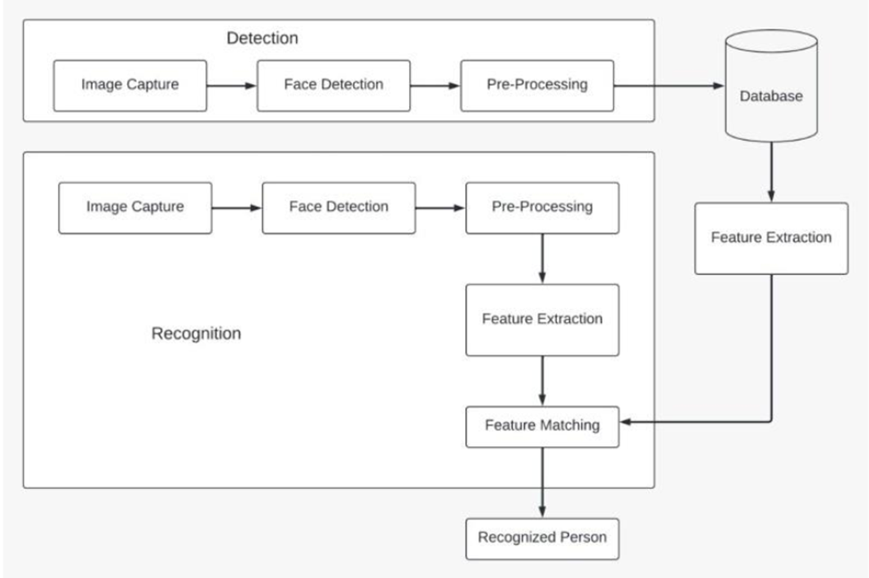

**Fig 4.1 System Architecture**

**4.4.1 Data Flow Diagrams**

The Data Flow Diagrams (DFDs) for this project illustrate the flow of information within the attendance management system, providing a clear visualization of how data is processed, transferred, and stored. These diagrams are structured across multiple levels to enhance understanding and granularity.

At Level 0, the DFD presents a high-level overview of the entire system, highlighting the main entities such as the Admin, Teacher, and Student, and their interactions with the central Attendance Management System. It shows the primary processes like managing classes, handling attendance records, and generating reports.

Moving to Level 1 and beyond, the DFDs break down these primary processes into more detailed sub-processes. For instance, the process of "Recording Attendance" is divided into steps like capturing student data, verifying attendance through RFID and facial recognition, and updating the attendance database. These detailed diagrams help in identifying specific data inputs, outputs, and storage points, ensuring a comprehensive understanding of the system's functionality.

Overall, the DFDs serve as essential tools for system analysis and design, enabling stakeholders to visualize data flows, identify potential bottlenecks, and ensure that all requirements are met through systematic data processing.

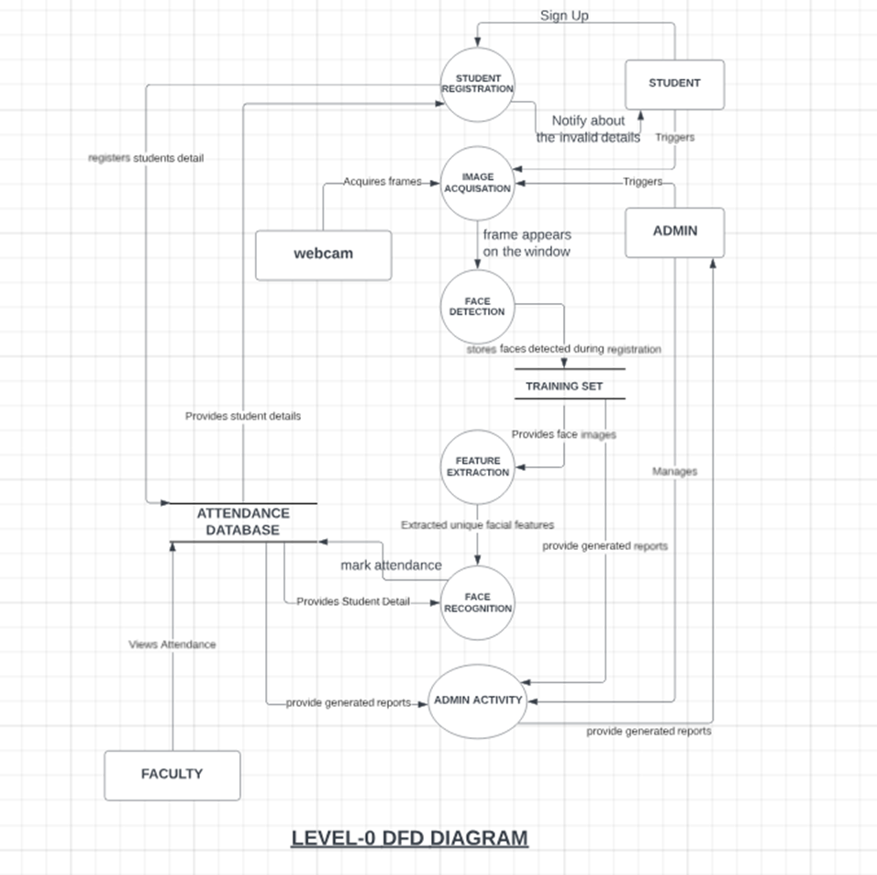

**Fig 4.2 Level-0 DFD Diagram**

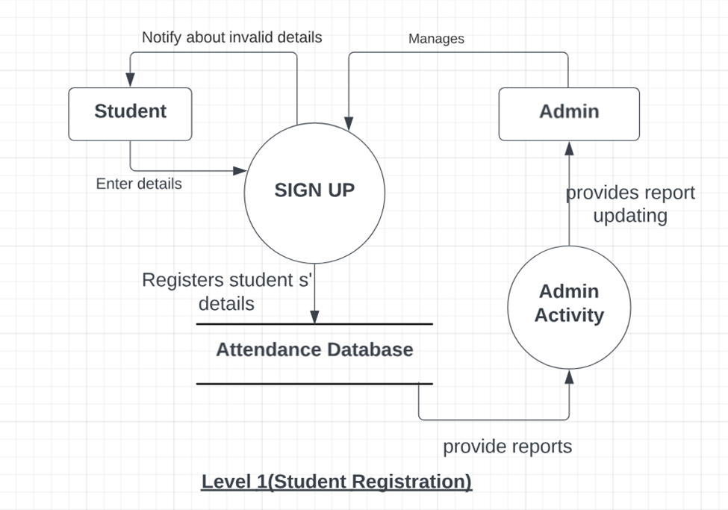

**Fig 4.3 Level 1 DFD Diagram**

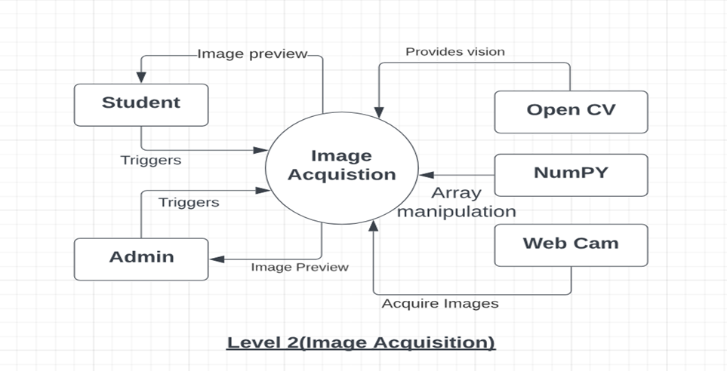

**Fig 4.4 level 2 DFD Diagram**

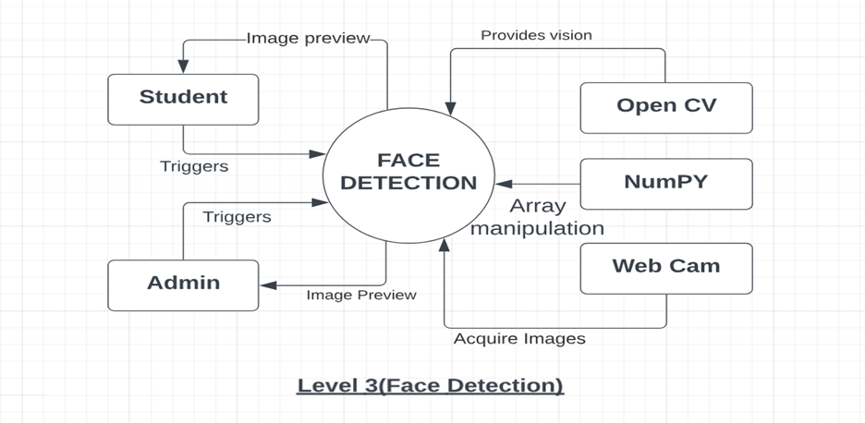

**Fig 4.5 Level 3 DFD Diagram**

**Fig 4.6 Level-4 DFD Diagram**

**4.4.2 Use Case Diagram**

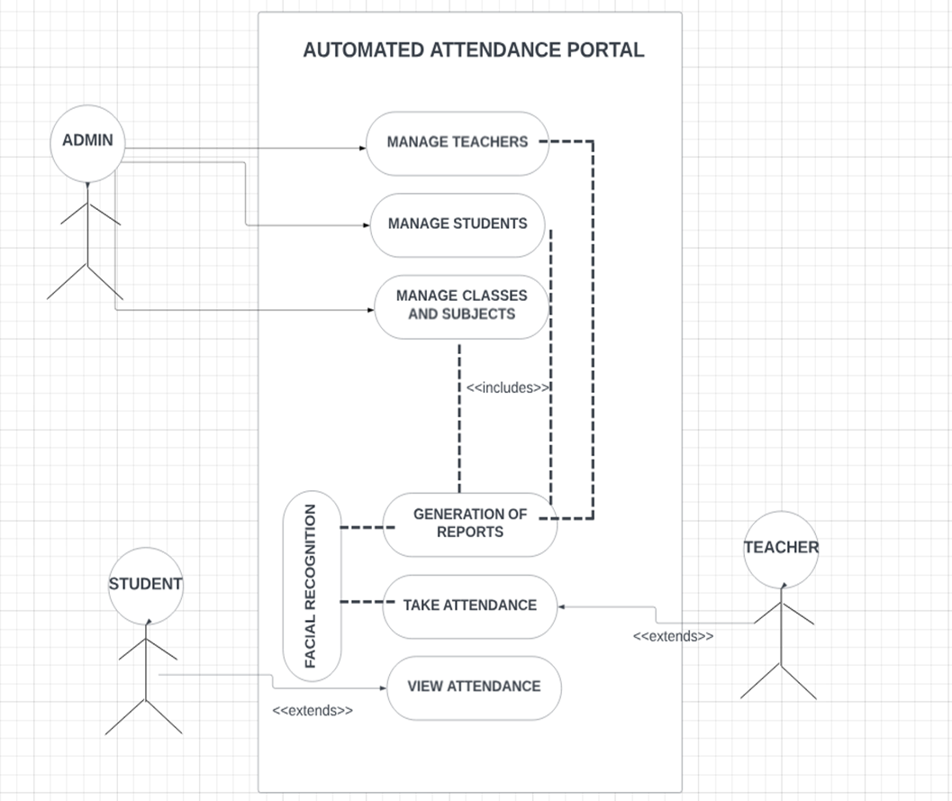

**Fig 4.7 USE CASE DIAGRAM**

**4.5 Database Design**

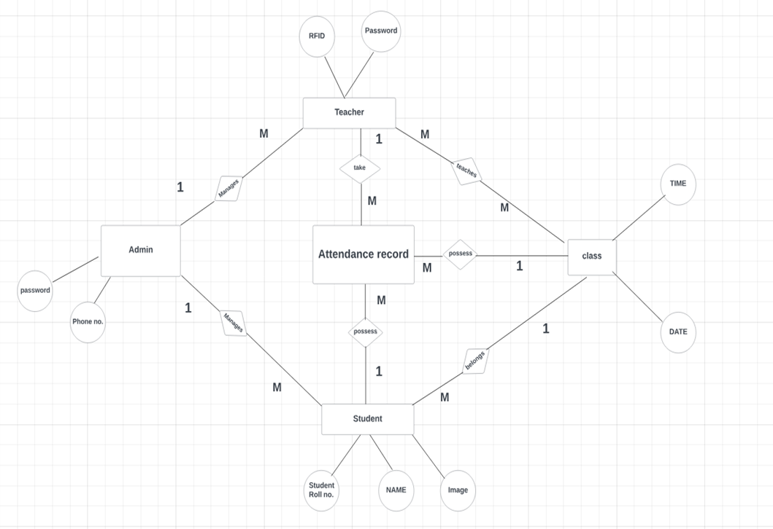

**Fig 4.8 ER Diagram**

**CHAPTER 5**

**IMPLEMENTATION**

**5.1 Introduction Tools and Technologies Used**

**Implemented Tools-:**

**1)Python**

Python is powerful and fast, plays well with others, runs everywhere, is friendly and easy to learn. Python source files use the " .py " extension and are called "modules."

There are no types of declaration of variables, parameters, functions, or methods in source code. This makes the code short and flexible, and you lose the compiler-time type checking.

of the source code. Python tracks the types of all values at run time and flags code that does not make sense as it runs.

**a) Features of Python-:**

(a). Small Core

(b). Clear, Concise, and Orthogonal Syntax.

(c). Self-Documenting

(d). Easy supports for default arguments (e). True object oriented and 'First Class classes and functions.

(f). Classes are used extensively in the standard library.

(g). Multiple Inheritance

(h). Object-Oriented file handling

(i). Method Chaining

(j). Everything is a reference.

(k). 'Del' statement for all data types

(l). Simple array slicing syntax.

(m). Consistent case sensitivity

(n). Operator overloading

(o). Structured exception handling

(p). Threading

**b) Python Modules Used in Portal**:

1)NumPy (for numerical computations and data manipulation in Python.)

2)Datetime (Used for handling date and time-related operations.)

3)Serial (Used for serial communication with external devices, such as RFID readers.)

4)Array (In Python, an array is a data structure that can hold a fixed-size sequence of elements of the same data type.)

**2)OpenCV (Open-Source Computer Vision Library)**

OpenCV (Open-Source Computer Vision Library) is an open-source computer vision and machine learning software library. It provides a wide range of functionalities for image and video processing, including object detection, face recognition, feature detection, image filtering, and more.

**Features Of Open CV-:**

1) Image Processing.

2)Video Processing.

3)Object Detection and Tracking.

4)Feature Detection and Description.

5)Image Filtering and Transformation.

6)Face Recognition and Biometrics.

7)Machine Learning Support.

8)Deep Learning Inference.

9)Graphical User Interface (GUI) Tools.

10)Camera Calibration and 3D Reconstruction.

Overall, OpenCV is a powerful and versatile library that is widely used in research, academia, and industry for a wide range of computer vision tasks and applications.

**Algorithms used in this project-:**

1) Haar Cascade Classifier (HCC A).

2) Local Binary Pattern Histograms (LBPH).

**3)PHP (Hypertext Preprocessor)**

PHP is a versatile and widely used programming language for web development, known for its simplicity, flexibility, and broad ecosystem of tools and resources. It continues to evolve with new features and improvements, making it a popular choice for building dynamic and interactive web applications.

**Features of PHP-:**

1)Server-Side Scripting.

2)Cross-Platform Compatibility.

3)Open Source.

4)Easy to Learn and Use.

5)Integration with Web Servers.

6)Database Connectivity.

7)Extensive Library of Functions.

8)Security Features.

**4)My SQL (My Structured Query Language)**

MySQL is an open-source relational database management system (RDBMS) that is widely used for building scalable, high-performance web applications. Developed by MySQL AB, which was later acquired by Sun Microsystems (now part of Oracle Corporation), MySQL is known for its reliability, ease of use, and comprehensive feature set.

MySQL is a robust, scalable, and feature-rich database management system that is widely used in web development, e-commerce, content management, social networking, and other applications.

**Features of My SQL-:**

1. Relational Database Management System (RDBMS).
2. Open Source.
3. Cross-Platform Compatibility.
4. Scalability and Performance.
5. SQL Support.
6. Replication and High Availability.
7. Backup and Recovery.
8. Security Features.
9. Indexes and Optimization.
10. Concurrency Control.

**Implemented algorithms-:**

**1)LBPH (Local Binary Histograms Patterns)**

Face recognition is essentially the task of identifying a person based on their facial appearance in computer science. In the past two decades, it has greatly increased in popularity, largely due to new techniques created and the excellent quality of the most recent recordings and cameras. The Local Binary Pattern (LBP) texturing operator labels each pixel in an image by thresholding its immediate surroundings and treating the result as a binary number. Furthermore, it has been discovered that using LBP in conjunction with HOG descriptors significantly enhances detection performance on specific datasets. We can express the images of faces using a straightforward data vector by using the LBP in conjunction with histograms. As LBP is a visual descriptor it can also be used for face recognition tasks, as can be seen in the following step-by-step explanation.

1) Parameters: the LBPH uses 4 parameters:

1. Radius: the radius is used to build the circular local binary pattern and represents the radius around the central pixel.
2. Neighbors: the number of sample points to build the circular local binary pattern. ·
3. Grid X: the number of cells in the horizontal direction. ·
4. Grid Y: the number of cells in the vertical direction.

2) Training the Algorithm: We must first train the algorithm. We must use a dataset containing the facial photographs of the persons we wish to identify to accomplish this. For the algorithm to identify an input image and provide you with a result, we also need to set a Student ID for each image.

3) Applying the LBP operation: The initial computational phase of the LBPH is to produce an intermediate image that, by emphasizing the face features, more accurately describes the original image. The algorithm does this by utilizing a sliding window idea based on the radius and neighbors of the parameter. Suppose we have a facial image in grayscale. We can get part of this image as a window of 3x3 pixels. It can also be represented as a 3x3 matrix containing the intensity of each pixel (0-255). The matrix's central value must then be used as the threshold, which is what we must do next. We establish a new binary value for each neighbor of the threshold value. The matrix will now only have binary values. Each binary value from each point in the matrix must be concatenated, line by line, into a new binary value. The central value of the matrix, which is a pixel from the original image, is then set to this binary value after being converted to a decimal value. At the conclusion of this process (the LBP technique), we obtain a new image that more accurately captures the traits of the original image.

4) Extracting the Histograms: As we have an image in grayscale, each histogram (from each grid) will contain only 256 positions (0-255) representing the occurrences of each pixel intensity. Then, we need to concatenate each histogram to create a new and bigger histogram.

5) Performing the face recognition: The algorithm has already been trained at this point. Each histogram produced serves as a representation of one of the training dataset's images. Therefore, given an input image, we repeat the process for the new image and produce a histogram that symbolizes the image. Simply compare two histograms and return the image with the closest histogram to identify the image that matches the input image. The distance between two histograms can be calculated using a variety of methods, such as the Euclidean distance, chi-square, absolute value, etc. So, the algorithm output is the ID from the image with the closest histogram. The algorithm should also return the calculated distance, which can be used as a ‘confidence’ measurement. We can then use a threshold and the ‘confidence ‘to automatically estimate if the algorithm has correctly recognized the image. We can assume that the algorithm has successfully recognized if the confidence is lower than the threshold defined.

**2)HCC A (Haar Cascade Classifier)**

Haar classifier, or a Haar cascade classifier, is a machine learning object detection program that identifies objects in an image and video. The algorithm can be explained in four stages:

1. Calculating Haar Features
2. Creating Integral Images
3. Using Adaboost
4. Implementing Cascading Classifiers

It’s important to remember that this algorithm requires a lot of positive images of faces and negative images of non-faces to train the classifier, like other machine learning models.

1) Calculating Haar Features: Gathering the Haar features is the initial stage. In a detection window, a Haar feature is effectively the result of calculations on adjacent rectangular sections. To calculate the difference between the sums, the pixel intensities in each region must first be added together. Identifying these elements in a large photograph can be challenging. This is where integral images come into play because the number of operations is reduced using the integral image.

2) Creating Integral Images: Without going into too much of the mathematics behind it, integral images essentially speed up the calculation of these Haar features. Instead of computing at every pixel, it instead creates sub-rectangles and creates array references for each of those sub-rectangles. These are then used to compute the Haar features.

3) AdaBoost Training: In essence, Adaboost selects the top features and trains the classifiers to use them. The algorithm can detect objects by using a "strong classifier" that is made by combining several "weak classifiers." By sliding a window across the input image and computing Haar characteristics for each area of the image, weak learners are produced. This distinction is contrasted with a learnt threshold that distinguishes between non-objects and objects. Since these are "weak classifiers," creating a strong classifier requires a lot of Haar features to be accurate.

4) Implementing Cascading Classifiers**:** Each level of the cascade classifier is made up of weak learners. It consists of a sequence of phases. A highly accurate classifier can be created from the mean prediction of all weak learners by employing boosting during the training of weak learners. The classifier either chooses to go on to the subsequent region (negative) or decides to indicate that an object was identified (positive) based on this prediction. Stages are made to reject negative samples as quickly as possible because the bulk of the windows don't contain anything of interest.

Haar-cascade is a method, in which it trains machine learning for detecting objects in a picture. It can be used to detect faces. The basic idea of the Haar-based face detector is that if you look at most frontal faces, the region with the eyes should be darker than the forehead and cheeks, and the region with the mouth should be darker than cheeks, and so on.

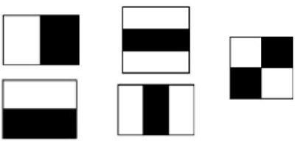

**Fig 5.1 The 5 Haar Like Features Used**

It typically performs about 20 stages of comparisons like this to decide if it is a face or not, but it must do this at each possible position in the image and for each possible size of the face, so in fact it often does thousands of checks per image. The name of this method is composed of two important words, Haar and Cascade. Haar belongs to Haar-like features which is a weak classifier and will be used for face recognition.

A Haar-like feature is a rectangle which is split into two, three or four rectangles. Each rectangle is black or white. This shows the different possible features. A Haar- cascade needs to be trained with various positive and negative pictures. The objective is to extract the combination of these features that represent a face. While a positive picture contains the object which must be recognized, a negative picture represents a picture without the object.

In the context of face detection, a positive picture possesses a face, and a negative picture does not. This machine learning requires grayscale pictures. The intensity of gray will be used to detect which feature is represented. These features can be found by calculating the sum of the dark pixels in an area subtracted by the sum of the bright pixels.

The 5 Haar-like features are used for detecting faces.

The basic principle in this method is based on are as follows:

* 1. Images are used in the integral representation that allows a machine to calculate the necessary object features.
  2. Using Haar-like features, the desired feature of the face can be found.
  3. Adaptive Boosting is used to select the most suitable characteristics for the desired object to this part of the image.
  4. All the features are input to the classifier, which gives the result true or false.

The extracted combination of features from the training part will be used for detecting faces in a picture. To detect a face in an unknown picture is the combination of the features will be researched. The features are tried to be matched only in a block of pixels defined by a scale. Each feature of the combination will be tried to be matched one by one in the block. If one of the features does not appear in the block, the research in it will be stopped. The remaining features will not be tested because the machine concludes that there is no face in this block. Then, a new block is taken, and the process will be repeated.

The 5 Haar-like features used for detecting faces pixels with the researched combination in cascade which explains the second word in the name of the method. This method is efficient to detect an image without faces because only a few tests need to be run to infer that the image does not contain a face. A face is consequently detected when each feature of the combination has been recognized correctly in a block. We can see that the eyes are darker than the cheeks and the middle of the nose is brighter. All these features which were extracted from the training are used to find a pattern to represent a face. The process will proceed block by block until the last one. After checking the last block, the scale is increased, and the detection process starts again. The process is repeated several times with different scales to detect faces of different sizes. Only a few pixels are different between two neighbor blocks. Therefore, each time a face is detected in a picture, the same face is detected in different blocks.

All the detected faces that concern the same person are merged and are considered as one at the end of the entire process. The accumulation of these weak classifiers builds a face detector able to detect faces very fast with suitable accuracy. A Haar- cascade classifier must be trained only once. Thus, it is possible to create one’s own Haar-cascade or use one which has already been trained.

**5.2 Dataset Description**

The dataset used in this attendance management system is integral to its functionality, ensuring accurate and efficient face recognition and attendance tracking. The dataset primarily consists of the following key components:

1. **Student Information:**
   1. **Attributes:**
      1. Roll Number: A unique identifier for each student.
      2. Name: The full name of the student.
      3. Image Path: The file path to the student's facial image.
   2. **Description:** This dataset holds the essential personal and identification information of each student enrolled in the class. Each entry in this dataset is linked to a facial image that is used for face recognition purposes.
2. **RFID and Class Data:**
   1. **Attributes:**
      1. RFID Tag: A unique RFID identifier assigned to each student.
      2. Class Name: The name of the class or section the student belongs to.
      3. Subject Name: The subject currently being attended.
      4. Teacher Name: The name of the teacher conducting the class.
      5. Teacher Email: The email address of the teacher.
   2. **Description:** This dataset connects the RFID tags scanned by students to their corresponding class schedules. It ensures that the attendance recorded is matched correctly to the student's current class and subject.
3. **Attendance Records:**
   1. **Attributes:**
      1. Date and Time: The date and time when the attendance was recorded.
      2. Class: The class for which attendance is being marked.
      3. Subject: The subject being taught at the time of attendance.
      4. RFID Tag: The RFID tag of the student present.
      5. Attendance Status: The status indicating whether the student is present or absent.
   2. **Description:** This dataset maintains a log of all attendance records, capturing the presence or absence of students in various classes over time. It is crucial for generating attendance reports and identifying attendance patterns.
4. **Facial Images:**
   1. **Attributes:**
      1. Grayscale Images: Images of student faces converted to grayscale.
   2. **Description:** The dataset includes grayscale images of students' faces used for training the face recognition model. Each image is pre-processed to ensure consistency and improve recognition accuracy. The images are stored in directories named after the corresponding students.

**Data Collection and Preprocessing**

1. **Data Collection:** The facial images are collected using a camera, capturing multiple images of each student to ensure a diverse set of training data. RFID tags are distributed to students, and their information is recorded in the system database.
2. **Preprocessing:** Facial images undergo preprocessing steps including resizing, grayscale conversion, and histogram equalization to standardize the input for the face recognition model. The dataset is then divided into training and testing sets to validate the model's accuracy.

**Data Storage** The datasets are stored in a relational database managed by MySQL, ensuring efficient retrieval and management of data. The images are stored in a structured directory format on the server, with metadata stored in the database for easy access and linking to student records.

**Utilization**

These datasets are utilized by various modules in the system:

* **Face Recognition:** Uses the facial image dataset to identify students during attendance capture.
* **Attendance Management:** Utilizes student and RFID data to log attendance records accurately.
* **Reporting and Analytics:** Leverages attendance records to generate reports and analyse attendance patterns.

This comprehensive dataset forms the backbone of the attendance management system.

**CHAPTER 6**

**Testing Techniques and Test Cases Used**

Testing is a crucial phase in the development of the attendance management system to ensure it functions correctly, efficiently, and reliably. The testing process involves various techniques and methodologies to validate different aspects of the system, including functionality, performance, security, and user experience.

**1. Unit Testing**

1. **Objective:** To test individual components or modules of the system to ensure they work as intended.
2. **Methodology:**
   1. Write test cases for each function and method in the code.
   2. Use a testing framework like **unit test** in Python to automate the execution of these test cases.
   3. Mock external dependencies (e.g., database connections) to isolate the component being tested.
3. **Example:**
   1. Test the getClassData function to ensure it correctly retrieves class data from the server.
   2. Test the getStudentOfClass function verify it fetches the correct list of students for class.
4. **Test Cases Used in This Project:**

**Test Case 1: Valid RFID Data Retrieval**

1. **Objective:** Verify that the getClassData function retrieves correct class data for a valid RFID.
2. **Input:** Valid RFID, current time.
3. **Expected Output**: Correct class data (class name, subject, teacher name, and email).

**Test Case 2: Invalid RFID Data Retrieval**

1. **Objective**: Verify that the getClassData function handles invalid RFID correctly.
2. **Input:** Invalid RFID, current time.
3. **Expected Output**: Error message indicating RFID not registered.

**Test Case 3: Student List Retrieval**

1. **Objective:** Ensure getStudentOfClass function retrieves the correct list of students for a given class.
2. **Input:** Valid class name.
3. **Expected Output:** List of student objects with correct details (roll number, name, image path).

**2. Integration Testing**

1. **Objective:** To test the interaction between different modules and ensure they work together as expected.
2. **Methodology:**
   1. Combine individual modules and test them as a group.
   2. Use integration test cases to verify the flow of data and control between modules.
3. **Example:**
   1. Test the integration of the RFID reader module with the class data retrieval and face recognition modules.
   2. Verify that the attendance submission process works correctly when combining the face recognition output with the attendance recording module.
4. **Test Cases Used in This Project:**

**Test Case 1: End-to-End Attendance Capture**

1. **Objective:** Verify the complete workflow from RFID scan to attendance recording.
2. **Input:** Valid RFID, current time, captured face images.
3. **Expected Output:** Successful attendance submission and correct record in the database.

**Test Case 2: RFID and Face Recognition Integration**

1. **Objective:** Test interaction between RFID reader and face recognition module.
2. **Input:** Valid RFID, face images.
3. **Expected Output:** Correct identification of faces and accurate attendance recording.

**3. System Testing**

1. **Objective:** To test the entire system to ensure it meets the specified requirements.
2. **Methodology:**
   1. Conduct end-to-end testing of the system, including all integrated modules and external interfaces.
   2. Perform functional testing to validate that the system performs the expected tasks and produces the correct outputs.
3. **Example:**
   1. Test the complete attendance capture and submission workflow, from scanning the RFID tag to recognizing the face and recording attendance in the database.
   2. Verify that the system handles various scenarios, such as unregistered RFID tags, invalid class times, and multiple students in the frame.
4. **Test Cases Used in This Project:**

**Test Case 1: Complete System Functionality**

1. **Objective:** Test the entire system functionality as a whole.
2. **Input:** Valid RFID, face images, class data.
3. **Expected Output:** End-to-end system works correctly, from RFID scanning to attendance submission.

**Test Case 2: Handling Multiple Students**

1. **Objective:** Verify system performance and accuracy with multiple students.
2. **Input:** Multiple RFID scans, multiple face images.
3. **Expected Output:** Correct attendance records for all students.

**4. Performance Testing**

1. **Objective:** To assess the system's performance under various conditions, including load and stress testing.
2. **Methodology:**
   1. Use performance testing tools to simulate multiple users and concurrent operations.
   2. Measure response times, throughput, and resource utilization.
3. **Example:**
   1. Test the system's performance when multiple RFID scans and face recognition processes occur simultaneously.
   2. Measure the time taken to process and submit attendance for a large class size.
4. **Test Cases Used in This Project:**

**Test Case 1: Load Testing**

1. **Objective:** Assess system performance under a high load of concurrent RFID scans and face recognitions.
2. **Input:** Simulated concurrent RFID scans and face recognitions.
3. **Expected Output:** System maintains performance without significant degradation.

**Test Case 2: Stress Testing**

1. **Objective:** Test system behaviour under extreme conditions.
2. **Input:** Extreme number of RFID scans and face recognitions beyond normal usage.
3. **Expected Output:** System handles stress gracefully, with appropriate error handling.

**V. Automation Testing-Selenium**

**Test Case 1: Admin Login**

**Fig-6.1 Admin Login**

**Fig 6.2 Teacher Login**

**Test Case 3-Admin Dashboard**

**Fig 6.3 Admin Dashboard**

**Test Case 4-Teacher Dashboard**

**Fig 6.4 Teacher Dashboard**

**CHAPTER 7**

**Results And Discussions**

**7.1 Description of Modules with Snapshots**

**Fig7.1 attendance_cam_virtual.py module**

**Description of the module-**

This module is the crucial module of this project as it deals with the facial recognition and management of the routes to other php modules of the website. Here is the breakdown of the code:

**A) Imports:** The script imports necessary libraries such as cv2 (OpenCV), numpy, requests (for making HTTP requests), datetime, and others.

**B) Configuration:** The script sets the CLASS_ROOM and port variables for configuration purposes.

**C) Date and Time Handling:** The script tries to parse a date string from the command-line arguments in a specific format (DD-MM-YYYY/HH:MM: SS). If the date string is not provided or is in an incorrect format, it exits.

**D) Class Definitions:**

1. Student class: Represents a student with properties like roll No, name, and image Path.
2. RfIdResponse class: Represents the response from the server when requesting class data for a given RFID tag.

**E) Helper Functions:**

1. getClassData: Sends a POST request to the server to get class data based on an RFID tag and the current time.
2. getStudentOfClass: Sends a POST request to the server to get a list of students for a given class.
3. getRollNoFromStudent: Retrieves the roll number of a student based on their image path.
4. submitAttendance: Sends a POST request to the server to submit attendance records for a class, subject, RFID tag, date, and a list of roll numbers.
5. submitLogRequest: Sends a POST request to the server to register an attendance request.

**F) Face Recognition:**

1. The getFacesFromImageProcessing function is responsible for face recognition using OpenCV.
2. It loads a pre-trained Haar cascade classifier for face detection.
3. It then trains a face recognition model using the Local Binary Patterns Histograms (LBPH) algorithm on a set of training images located in the att_faces directory.
4. The function captures frames from the webcam, detects faces, and tries to recognize them using the trained model.
5. If a face is recognized, it displays the name and confidence score on the frame. If not, it displays "not recognized".
6. The function returns a list of names of recognized faces.

**G) Main Loop:**

1. The script enters a loop where it prompts the user to enter an RFID tag ID.
2. If a valid RFID tag ID is entered, it performs the following steps:
   1. Calls getClassData to get class information based on the RFID tag and the current time.
   2. If the class information is valid, it calls getStudentOfClass to get a list of students for that class.
   3. Calls getFacesFromImageProcessing to perform face recognition and get a list of recognized faces.
   4. Matches the recognized faces with the list of students to get their roll numbers.
   5. Calls submitAttendance to submit the attendance records to the server.

**Fig 7.2 Train.py module**

**Description of the module-**

This Python script, named train.py, is designed to capture and save face images for training a face recognition model. Here's a breakdown of the code:

1. **Importing Libraries**: The script imports necessary libraries, including OpenCV (cv2), NumPy, and os.
2. **Setting Parameters**: The script sets some parameters, such as the maximum number of images to capture (count_max), the size of the image for faster processing (size), the path to the Haar Cascade classifier (fn_haar), and the directory to store the captured images (fn_dir).
3. **Obtaining the Name for Image Storage**: The script expects a name as a command-line argument, which is used as the subdirectory name to store the captured images.
4. **Creating the Subdirectory**: If the subdirectory for the given name doesn't exist, the script creates it.
5. **Initializing Image Dimensions, Haar Cascade Classifier, and Webcam**: The script sets the dimensions for the resized face images (im_width, im_height), loads the Haar Cascade classifier (cv2.CascadeClassifier), and initializes the webcam (cv2.VideoCapture).
6. **Generating a Unique File Name**: The script generates a unique file name for the captured images by finding the highest existing number in the subdirectory and incrementing it.
7. **Printing a Message**: The script prints a message informing the user about the number of samples to be captured and instructing them to move their head around for better diversity.
8. **Capturing and Saving Images**: The script enters a loop to capture and save the specified number of images (count_max). Inside the loop:
   1. It reads frames from the webcam (webcam.read()).
   2. It flips the frame horizontally (cv2.flip()).
   3. It converts the frame to grayscale (cv2.cvtColor()).
   4. It resizes the grayscale image for faster processing (cv2.resize()).
   5. It detects faces in the resized image using the Haar Cascade classifier (haar_cascade. detectMultiScale()).
   6. If a face is detected, it extracts the face region, resizes it to the specified dimensions (im_width, im_height), and saves it as a PNG file in the subdirectory with the generated file name.
   7. It also draws a green rectangle around the detected face and displays the name provided as a command-line argument.
   8. To introduce diversity in the captured images, it only saves every fifth detected image.
   9. It displays the processed frame (cv2.imshow('OpenCV', frame)).
9. **Handling User Input**: The script checks for the 'Esc' key press (cv2.waitKey(10)). If the 'Esc' key is pressed, the loop breaks, and the program exits.

This script is typically used as a part of the face recognition pipeline, where the captured images are used to train a face recognition model. The trained model can then be used for face recognition tasks, such as attendance tracking or access control systems.

**Fig 7.3 Variety of PHP modules**

**Description of module-:**

In your attendance management system, several PHP modules play a crucial role in creating a robust and efficient full-stack website. These modules ensure seamless integration of facial recognition for logging student attendance and maintaining a corruption-free database. Here's a detailed overview of how these modules function and contribute to the system's robustness and efficiency:

1. **User Authentication Module**
   1. Purpose: Handles user login and authentication, ensuring that only authorized personnel (teachers, administrators) can access the system.
   2. Functionality:
      1. Login form validation
      2. Password hashing and verification.
      3. Session management
      4. Role-based access control
   3. Impact: Ensures secure access to the system, preventing unauthorized use and protecting sensitive data.
2. **RFID and Class Data Retrieval Module**
   1. Purpose: Retrieves class schedule and associated information based on the RFID input.
   2. Functionality:
      1. Fetches class details, subject, teacher information using RFID from the database.
      2. Validates the current time with the class schedule to ensure accurate attendance logging.
   3. Impact: Provides the necessary context for attendance logging, ensuring that the system accurately associates attendance data with the correct class and time.
3. **Student Data Management Module**
   1. Purpose: Manages student information including their images for facial recognition.
   2. Functionality:
      1. CRUD operations (Create, Read, Update, Delete) for student data.
      2. Stores and retrieves student images from the server.
   3. Impact: Maintains an up-to-date database of student information which is critical for accurate face recognition and attendance logging.
4. **Face Recognition Integration Module**
   1. Purpose: Integrates the facial recognition process with the PHP backend.
   2. Functionality:
      1. Receives and processes the results of facial recognition.
      2. Matches recognized faces with stored student images.
   3. Impact: Ensures that the system can reliably identify students based on their facial features, contributing to accurate and efficient attendance logging.
5. **Attendance Logging Module**
   1. Purpose: Records attendance data into the database.
   2. Functionality:
      1. Validates and processes attendance data received from the facial recognition module.
      2. Logs the attendance for each student along with timestamps.
   3. Impact: Provides a reliable mechanism for recording attendance data, ensuring accuracy and integrity in the attendance records.

6. **Database Management Module**

* 1. **Purpose:** Manages database connections and operations to ensure data integrity and security.
  2. **Functionality:**
     1. Establishes secure connections to the MySQL database.
     2. Executes SQL queries for data retrieval and manipulation.
     3. Implements data validation and error handling to prevent SQL injection and other attacks.
  3. **Impact:** Ensures a corruption-free database by maintaining data integrity and security through proper handling of database operations.

**7.2 Key Findings of The Project**

This project, focused on developing a robust attendance management system using facial recognition technology, has yielded several key findings. These insights highlight the effectiveness of integrating advanced technologies with traditional attendance systems and underscore the benefits of such an approach.

**1. Accuracy of Facial Recognition Technology**

One of the primary findings is the high accuracy of facial recognition technology in identifying students. By leveraging Local Binary Patterns Histogram (LBPH) for face recognition, the system can accurately detect and match faces against stored images. This accuracy significantly reduces instances of proxy attendance, ensuring that only present students are marked as present.

**2. Efficiency in Attendance Logging**

The integration of RFID technology with facial recognition has streamlined the attendance logging process. The system efficiently matches the RFID input with class schedules and student data, enabling quick and accurate attendance recording. This efficiency not only saves time but also minimizes manual errors associated with traditional attendance methods.

**3. Data Integrity and Security**

A critical finding is the importance of maintaining data integrity and security. The system's PHP modules and MySQL database management ensure that all attendance records are securely stored and protected against corruption. Proper validation and error handling mechanisms safeguard the database from unauthorized access and data breaches.

**4. User-Friendly Interface**

The project highlights the necessity of a user-friendly interface for seamless interaction. Teachers and administrators can easily navigate the system, access attendance reports, and monitor student attendance patterns. The intuitive design of the interface contributes to higher user acceptance and satisfaction.

**5. Scalability and Flexibility**

The modular architecture of the system allows for scalability and flexibility. The system can handle many students and classes, making it suitable for educational institutions of varying sizes. Additionally, the modular design enables easy updates and enhancements, ensuring that the system can adapt to future requirements.

**6. Operational Feasibility**

Operational feasibility is demonstrated through the system's ability to integrate with existing educational infrastructures. The system seamlessly works with current schedules, student databases, and institutional policies, ensuring smooth implementation and operation. This compatibility reduces the learning curve and training needs for users.

**7. Increased Student Accountability**

The use of facial recognition technology enhances student accountability. Students are aware that their presence is being tracked accurately, which discourages absenteeism and encourages punctuality. This increased accountability contributes to better student engagement and academic performance.

**8. Customization and Adaptability**

The system's design allows for customization and adaptability to meet specific institutional needs. Educational institutions can tailor the system to their unique attendance policies, schedules, and reporting requirements. This adaptability ensures that the system can cater to diverse educational environments effectively.

**7.3 Brief Description of Database with Snapshots**

**Fig 7.4 Subjects Schema**

**Description of the schema-**

The subject’s schema is a critical component of the attendance management system, acting as the backbone for organizing and managing academic subjects within the institution. This schema not only facilitates the systematic tracking of subjects but also ensures seamless integration with other components of the system, such as student attendance records, class schedules, and teacher assignments.

**Schema Design Overview**

The subject’s schema is designed to store detailed information about each academic subject offered by the institution. It typically includes the following fields:

* SubjectID: A unique identifier for each subject, ensuring distinct and unambiguous reference within the database.
* SubjectName: The name of the subject, such as Mathematics, English, or Physics.
* SubjectCode: A code assigned to the subject for easy reference, often used in class schedules and reporting.
* ClassID: A foreign key linking the subject to the specific class or grade level it is taught in.
* TeacherID: A foreign key linking the subject to the teacher responsible for teaching it.

**Benefits of the Subjects Schema**

* **Organization and Clarity**: The schema provides a structured way to manage subjects, ensuring clarity and organization within the academic framework.
* **Consistency**: By standardizing subject codes and names, the system ensures consistency across schedules, reports, and records.
* **Scalability**: The schema design allows for easy addition of new subjects, classes, and teachers, supporting the institution's growth and changing academic needs.
* **Enhanced Data Management**: With comprehensive subject data, the system can generate detailed reports and analytics, aiding in academic planning and decision-making.

**Fig 7.5 Students Schema**

**Description of the schema**-

The student’s schema is a fundamental element of the attendance management system, designed to organize and manage student information efficiently. It plays a pivotal role in ensuring accurate tracking of attendance, managing student-related data, and facilitating seamless interaction with other system components, such as class schedules, subject enrolments, and attendance records.

**Schema Design Overview**

The student’s schema is structured to store comprehensive information about each student enrolled in the institution. It includes various fields that capture both personal and academic details, ensuring a holistic view of each student's profile. The typical fields in the student’s schema are:

* **StudentID**: A unique identifier for each student.
* **FirstName**: The first name of the student.
* **LastName**: The last name of the student.
* **ClassID:** A foreign key linking the student to their respective class.
* **Roll No:** The roll number assigned to the student within their class.
* **Image Path:** The path to the student's photograph, used for facial recognition.

**Benefits of the Students Schema**

* **Comprehensive Data Management**: The schema ensures all relevant student information is captured and organized systematically, enabling efficient data management.
* **Automation and Accuracy**: By integrating with the facial recognition system, the schema supports automated attendance logging, reducing errors and ensuring accuracy.
* **Enhanced Communication**: Storing contact details allows for effective communication between the institution, students, and guardians.
* **Scalability and Flexibility**: The schema design allows for easy addition of new fields and students, supporting the institution's growth and changing needs.
* **Data-Driven Decision Making**: The detailed student data enables comprehensive reporting and analytics, aiding in informed decision-making and strategic planning.

**7.4 User Interface Representation**

**Fig 7.6 Subjects Panel**

**Fig 7.7 Teachers Panel**

**Fig 7.8 Timetable Panel**

**Fig 7.9 Classes Panel**

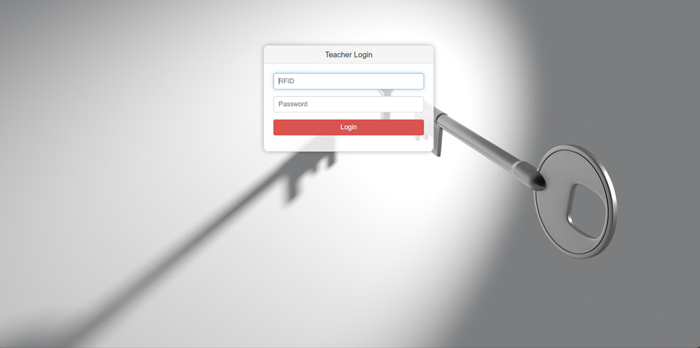 **Fig 7.10 Teacher Login**

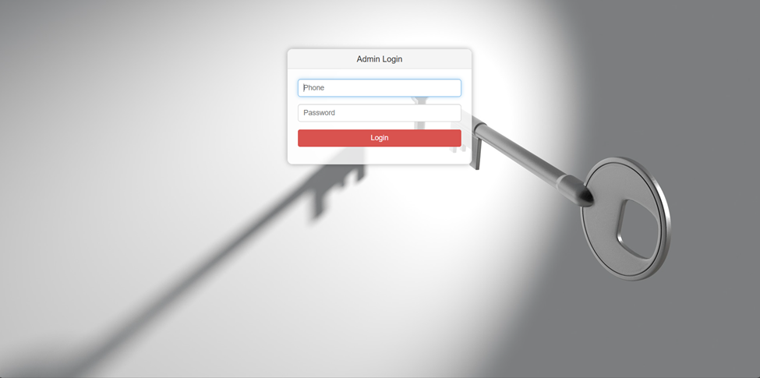

**Fig 7.11 Admin Login**

**7.5 Presentation of Results**

**Fig 7.12 Practical Testing**

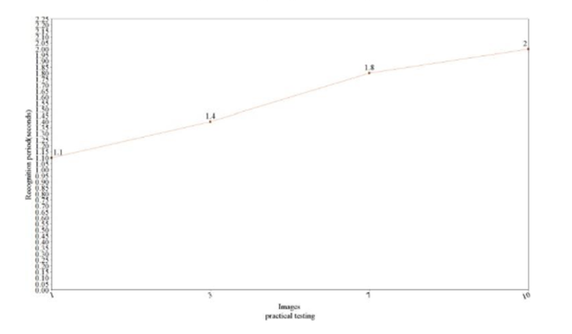 **Fig 7.13 Practical Testing 1**

**Fig 7.12** depicts the comparison between the training time and the number of images in the data set. And, finally, **Fig 7.13** compares the recognition time it takes the system to recognize n number of faces.

**7.5 Performance Evaluation**

The users can interact with the system using a GUI. Here, users will be mainly provided with three different options such as student registration, faculty registration, and mark attendance.

1. The students are supposed to enter all the required details in the student registration form. After clicking on the register button, the webcam starts automatically.
2. The webcam will capture 50 images to create the image dataset and then terminate automatically.
3. At the time of forming the image dataset, each student will get designated using an id number. While recognition, when the test student image matches with the dataset then the details of the student in the attendance excel sheet will be marked with a timestamp, if the test student image does not get matched with the dataset, then it will not be marked present, and all the unmatched students will be marked as absent after a certain period.

The following Images shows the nature of the system when it is fed with different size of datasets. Here we compare 3 groups of 2 data.

|  |  |  |
| --- | --- | --- |
| **View (Distance between camera and face between 35-100cm approx.)** | **ANGLE (In Degrees)** | **Recognition Rate in Normal Light Conditions** |
| **LEFT** | **30**  **45**  **90** | **100**  **99**  **0** |
| **CENTRE** | **0** |  |
| **RIGHT** | **30**  **45**  **90** | **100**  **97**  **0** |

**Table 7.1 Recognition Rate at Different Angles**

For Left view, between,0 and 45 degrees the recognition rate is 99-100 percent. After 45 degrees the rate starts decreasing and goes to zero at 90 degrees angles. For Right view, between,0 and 45 degrees the recognition rate is 97-100 percent. After 45 degrees the rate starts decreasing and goes to zero at 90 degrees angles. And, for 0 degrees, the recognition rate is 100 percent.

**CHAPTER 8**

**Conclusions and Future Scope**

The Attendance Management System utilizing facial recognition technology stands as a testament to the power of integrating modern technological advancements into traditional educational processes. This project addresses a critical need in educational institutions by providing a seamless, automated solution for tracking student attendance. The system leverages sophisticated machine learning algorithms and real-time data processing to ensure that attendance is recorded accurately and efficiently, eliminating the need for manual entry and the errors associated with it.

One of the most significant achievements of this project is its ability to operate in real-time, using facial recognition technology to identify students and mark their attendance. This not only saves valuable time for educators but also ensures that the process is tamper-proof, thereby maintaining the integrity of attendance records. The use of RFID technology further enhances the system's robustness, ensuring that each student's attendance data is securely linked to their unique identifier. The comprehensive backend database, implemented using MySQL and managed via an Apache server, ensures that all attendance data is securely stored and easily retrievable for analysis and reporting.

The system's design includes several PHP modules that contribute to its overall efficiency and reliability. These modules handle various functions, such as student registration, class and subject management, attendance logging, and report generation. By distributing the workload across these modules, the system can efficiently manage large amounts of data and support multiple users simultaneously. This modular approach also facilitates maintenance and updates, allowing for continuous improvements and scalability.

Looking ahead, there are numerous avenues for enhancing and expanding the capabilities of this Attendance Management System. One potential area for development is the integration of more advanced deep learning algorithms. These algorithms could improve the system's accuracy and speed, even in challenging conditions such as varying lighting or partial occlusions of students' faces. By incorporating techniques like convolutional neural networks (CNNs) and recurrent neural networks (RNNs), the system could achieve near-perfect recognition rates.

Another exciting prospect is the development of mobile applications for the system. By creating mobile versions for both iOS and Android platforms, the system could offer even greater flexibility and convenience. Educators and administrators could take attendance from anywhere within the institution, and students could use their mobile devices for identification, streamlining the process further.

In addition to technological advancements, integrating the system with other educational tools and platforms could provide a more holistic view of student engagement. For instance, linking the Attendance Management System with Learning Management Systems (LMS) would allow for a comprehensive analysis of student participation and performance. Educators could correlate attendance data with academic performance, helping to identify students who may need additional support.

Furthermore, the implementation of advanced analytics and predictive models could offer deeper insights into student behaviour and attendance patterns. By analyzing historical attendance data, the system could identify trends and predict potential issues, enabling proactive interventions. For example, if a student shows a pattern of declining attendance, the system could alert educators to check in with the student and provide necessary support.

Another future enhancement could involve incorporating biometric technologies beyond facial recognition. Fingerprint scanning, voice recognition, and iris scanning are additional methods that could be integrated to provide multi-modal biometric authentication, further increasing the system's accuracy and security.

In conclusion, the Attendance Management System is a pioneering project that successfully addresses the need for efficient, accurate, and secure attendance tracking in educational institutions. Its current implementation showcases the potential of facial recognition technology and RFID integration in streamlining administrative processes. With future developments in deep learning, mobile application development, system integration, and advanced analytics, the system can evolve into a comprehensive tool that not only manages attendance but also enhances the overall educational experience. By continuing to innovate and adapt, this project has the potential to set new standards for attendance management and contribute significantly to the field of educational technology.

**REFRENCES**

[1] Shreyak Sawhney, Karan Kacker, Samyak Jain, Shailendra Narayan Singh, Rakesh Garg, “Real-Time Smart Attendance System using Face Recognition Techniques”, 2020

[2] Naman Gupta, Purushottam Sharma, Vikas Deep, Vinod Kumar Shukla, “Automated Attendance System Using OpenCV”, 2019

[3] Krishna Mridha, Nabhan Tawjih Yousef, “Study and Analysis of Im- plementing a Smart Attendance Management System Based on Face Recognition Technique using OpenCV and Machine Learning”, 2021

[4] Organization, S. D. I. W. C., Kuster, B. (2018). Face Detection and Face Recognition in Python Programming Language. The Seventh International Conference on Informatics and Applications (ICIA2018).

[5] Emami, Shervin Suciu, Valentin. (2012). Facial Recognition using OpenCV. Journal of Mobile, Embedded and Distributed Systems.

[6] Yuvaraj, C. Srikanth, M. Kumar, V. Srinivasa Murthy, Y.V. Koolagudi, Shashidhar. (2017). An approach to maintain attendance using image processing techniques. 1-3. 10.1109/IC3.2017.8284353.

[7] Nirmalya Kar, Mrinal Kanti Debbarma, Ashim Saha, and Dwijen Rudra Pal. Study of Implementing Automated Attendance System Using Face Recognition Technique. International Journal of Computer and Commu- nication Engineering, Vol. 1, No. 2, July 2012.

[8] Suma S L, Sarika Raga, “Real Time Face Recognition of Human Faces by using LBPH and Viola Jones Algorithm,” International Journal of Scientific Research in Computer Science and Engineering, Vol.6, Issue.5, pp.6-10, 2018.

**Research Paper Acceptance Proof**

**Research paper.**

**Proof of patent publication (screenshot of publication)**